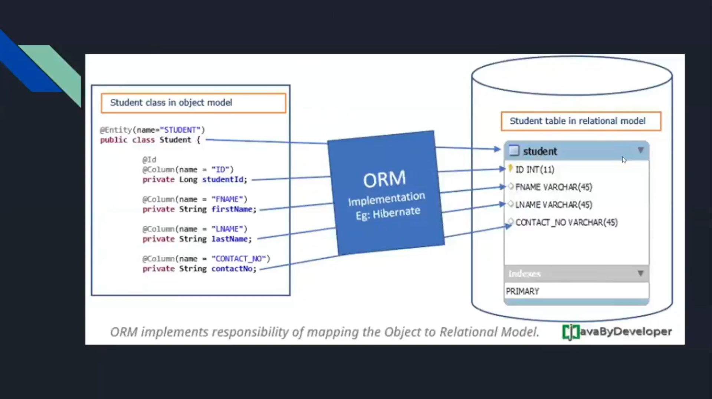
@Entity
@Table(name="sinhvien")
public class SinhVien {
@Id
@GeneratedValue(strategy = GenerationType.IDENTITY)
@Column(name = "id_sinhvien")
private int idSinhvien;
@Column(name = "hodem",nullable = false,length = 200)
private String hoDem;
@Column(name = "ten",nullable = false,length = 200)
private String ten;
@Column(name = "email",nullable = false,length = 200)
private String email;
}

